Quick reminder : The Simple Past
1 – Completed action in the past
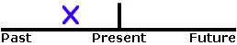
I saw a movie yesterday.
I didn't see a play yesterday.
Last year I traveled to Japan.
Did you have dinner last night?
2 – A series of completed actions in the past
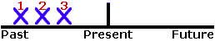
The past simple is used in a sequence of events and actions in the past, for example in stories and biographies.
I finished work, walked to the beach, and found a nice place to swim.
He arrived from the airport at 8:00, checked into the hotel at 9:00, and met the others at 10:00.
Did you add flour, pour in the milk, and then add the eggs?
3 – Habits in the past
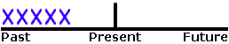
The past simple is also used to express past habits and routines.
As a child I used to get up quite early. I first got washed and dressed and then had my breakfast, which usually consisted of cereals with some fresh fruit juice, followed by some toasts and marmalade. I never left the house with an empty stomach.

